**Key messages**

Traditionally infection control experts have focussed on preventing transmission of water-related organisms such as *P. aeruginosa* and Legionella spp. More recently healthcare associated transmission of multi-resistant organisms (MROs) and even norovirus through environmental dispersal have become areas of priority.

There is a proven transmission path from drains and sink drains that are contaminated with potentially pathogenic bacterial biofilms including carbapenemase-producing and other multi-resistant organisms. (Kotsanas et al., 2013)

Contamination occurs through splashing to adjacent counter surfaces and patient care equipment (Kotay, Chai, Guilford, Barry, & Mathers, 2017) and often leads to infection particularly among highly compromised patients including ICU patients, transplant recipients and neonates.

The role of biofilm and its disruption including dispersal through splashing is being increasingly understood. This is of particular concern given the high rates of drain and sink colonisation (estimated to be between 16% to 100% in outbreaks).

The design of existing hospital wastewater drainage (WWD) is thought to be problematic and increasingly so when healthcare worker behaviours, including disposal of water contaminated with human pathogens, waste and fluids and/or discarded medications in sinks simultaneously used for hand hygiene and/or located close to where patient care is delivered, promote transmission.

Some investigators suggest that re-design of WWD is needed. This may include repositioning of a drain or a tap to avoid direct splashing into the drain which is thought to promote biofilm dispersal.

Despite various topic applications and use of disinfectant agents the persistence of potentially pathogenic bacterial biofilm is also a cause for concern yet in some cases even WWD replacement has failed to lessen the bioburden suggesting perhaps that methods of reducing dispersal are more urgently needed.(Carling, 2018)

Given the global urgency of antimicrobial resistance and its potential toll on humanity healtcahre facilities have an obligation to design and maintain areas in which patients are cared for in ways that minimise rather than increase the risk of acquiring any healthcare associated infection but especially a multi-resistant organism.

**Existing Australian Guidelines**

References about the role of sinks and drains in transmission of healthcare associated infections in the 2019 NHMRC *Australian Guidelines for the Prevention and Control of Infection in Healthcare* are from 2004 or prior thereby not addressing the increasing volume of more recent research, modelling and outbreaks reports outlining the extent of contaminated WWDs and their significant role in bacterial transmission.

The *Australasian Health Infrastructure Alliance (AHIA). The Australasian Health Facility Guidelines (AusHFG) Revision 7: 2016. Part D – Infection Prevention and Control* make some minor mention of WWDs primarily in the context of the previous version of the NHMRC *Australian Guidelines for the Prevention and Control of Infection in Healthcare* which were equally lacking. Appendix 1 is a replication of the relevant section in the AusHFGs.

**Summary of evidence**

**Kotay S, Chai W, Guilford W, Barry K, Mathers AJ. Spread from the Sink to the Patient: In Situ Study Using Green Fluorescent Protein (GFP)-Expressing Escherichia coli To Model Bacterial Dispersion from Hand-Washing Sink-Trap Reservoirs. Appl Environ Microbiol. 2017;83(8):e03327-16.(Kotay et al., 2017)**

Kotay modelled dispersion green fluorescent protein (GFP)-expressing Escherichia coli from sink wastewater to the surrounding environment.

When the GFP-expressing E. coli cells were allowed to mature in the P-trap under conditions similar to those in a hospital environment, a GFP-expressing E. coli-containing putative biofilm extended upward over 7 days to reach the strainer. This subsequently resulted in droplet dispersion to the surrounding areas (_30 in.) during faucet operation.

Many recent reports demonstrate that sink drain pipes become colonized with highly consequential multidrug-resistant bacteria, which then results in hospital-acquired infections.

A staged mode of transmission involving bioﬁlm growth from the lower pipe to the sink strainer and subsequent splatter to the bowl and surrounding area occurs rather than splatter directly from the water in the lower pipe. We have also demonstrated that bacterial transmission can occur via connections in wastewater plumbing to neighboring sinks.

Recently been an alarming increase in sink-related outbreaks worldwide, with many reports establishing an observational link. A sink often operates as an open conduit to wastewater in a patient care area that is often in the same room as the patient.

The wet, humid, and relatively protected environment in a sink trap favors the formation of rich stable microbial communities. These communities will be exposed to liquids and waste that are discarded in a sink and may include antimicrobials, discarded beverages, soap, presumably pathogenic bacteria from health care workers’ hands, and other items. In short, sink traps could serve as a breeding ground for opportunistic and highly antimicrobial-resistant bacteria that cannot be easily cleaned or removed.

(i) can organisms grow retrograde from the P-trap water to the sink strainer,

(ii) can organisms spread from one sink to another along the internal surfaces of pipes

with shared drainage systems

(iii) which portion of a colonized drain pipe results in dispersion into the sink bowl during a hand-washing event?

The retained water in a sink P-trap is present to provide a water barrier to prevent

off-gassing of sewer smell, but it may inadvertently provide favourable conditions for

pathogenic and opportunistic antibiotic-resistant microorganisms to survive and develop

resilient biofilms.

The two possible mechanisms for P-trap strainers becoming colonized are seeding of organisms from above and retrograde spread of organisms along common pipes in a hospital wastewater infrastructure.

In summary, this work for the first-time better models the mechanisms of spread of

multidrug-resistant pathogens arising from the sink drain and infecting patients. Droplet

dispersion from the P-trap does not happen directly. Rather it is a multistage

process: dispersal originates from the strainer and/or the bowl after growth of the

biofilm up from the microbial reservoir of the P-trap.

**Gormley M, Templeton K, Kelly D, Hardie A. Environmental conditions and the prevalence of norovirus in hospital building drainage system wastewater and airflows. Building Services Engineering Research & Technology. 2014;35(3):244-53**.(Gormley, Templeton, Kelly, & Hardie, 2014)

Typically, infection control concerned with *legionella pneumophila* and *psuedonomas aeruginosa.*

Fluid flows in building drainage systems (BDSs) are driven by random discharges from appliances leading to transient effects in the system, which may compromise the main seal between the sewer and the habitable space—the water trap seal, more commonly known as the ‘U-bend’.

Once a seal has been compromised, it then becomes a vent for the entire sewer system leading to the possibility of harmful pathogens entering the habitable space.

Now require closer monitoring and investigation of the ongoing operation of a BDS.

The hypothesis is that aerosolised virus-laden droplets can act as a transport medium through the BDS and that, with an appropriate assay, this transmission route can be confirmed.

BDS is contaminated when there is an infection in a hospital. There is a possibility of virus-laden droplets to circulate within the drainage system and emerge elsewhere. A collection drain is a reservoir for potentially harmful pathogens in hospitals.

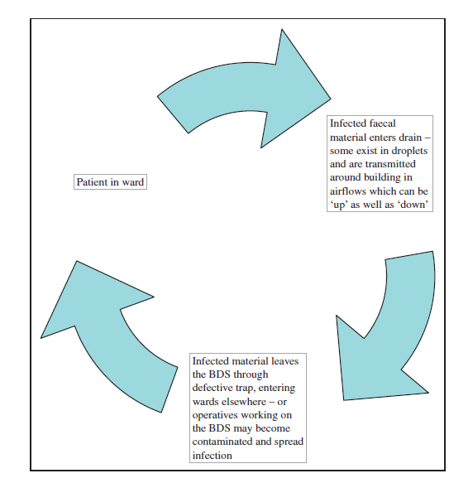

**Buchan BW, Graham MB, Lindmair-Snell J, Arvan J, Ledeboer NA, Nanchal R, et al. The relevance of sink proximity to toilets on the detection of Klebsiella pneumoniae carbapenemase inside sink drains. American Journal of Infection Control. 2019;47(1):98-100.(Buchan et al., 2019)**

Recent findings demonstrate that sink drains can be highly contaminated with carbapenemase-producing organisms, potentially splashing to adjacent counter surfaces and patient care equipment. The duration of colonization or persistence of these organisms in sink drains is unknown

The blaKPC gene was detected in 25 of 46 (54.3%) of sink drain specimens tested directly by PCR (Table 1). Direct PCR was positive in 20 of 23 (87.0%) sinks located near the toilet compared with only 5 of 23 (21.7%) sinks located near the room entry door (P < .00001; Table 1). In 4 of 5 (80.0%) rooms with a positive testing entry door sink, the sink near the toilet was also positive, suggesting a potential source for cross-contamination within the same room.

We found a high prevalence of *Klebsiella pneumoniae* carbapenemase(KPC) positivity in sink drains, especially next to toilets, when interrogated using a direct PCR method.

Based on recent data by Mathers and colleagues, it could be plausible that contamination of sinks next to toilets is occurring through biofilms growing in communal pipes between toilets and sinks. Alternatively, toilets are known to generate contaminated droplets during flushing; thus contamination of sink drains via droplets would not be unreasonable. Finally, the seeding of sinks may result from independent events such as the conduct of routine hand hygiene by patients or health care workers. Further studies examining the genetic clonality of bacterial isolates and plasmids are under way to test these hypotheses.

In conclusion, a high prevalence of blaKPC positivity was found in sink drains of a unit with no known recent history of KPC-producing organisms. The significance of these findings and the potential risk of transmission of KPC-producing organisms in absence of culturable bacterial strains is still unclear in terms of infection control. Our findings should be validated in other settings and institutions because the infection control implications are major. If sinks next to toilets are indeed a reservoir for blaKPC, then additional interventions such as modified hand hygiene practices (eg, dedicated sinks), optimization of sink disinfection protocols (eg, increased frequency, optimal disinfectants), and use of engineering controls (eg, splash shields) may be needed to further mitigate the risk of transmission of KPC producing organisms among health care providers and patients.

**Parkes LO, Hota SS. Sink-Related Outbreaks and Mitigation Strategies in Healthcare Facilities. Current Infectious Disease Reports. 2018;20(10).(Parkes & Hota, 2018)**

Ironically, hospital sinks are rich microbial breeding grounds and reservoirs for the transmission of nosocomial pathogens and resistance genes

Over the past 5 years, there has been an explosion of such outbreak reports, involving an ever-expanding

patient population and pantheon of microorganisms.

Waterborne bacteria predominate in sink-related outbreaks, with P. aeruginosa being the most commonly identified organism. Other pathogens include Enterobacteriaceae, such as *Escherichia coli,* *Klebsiella pneumoniae,* *Klebsiella oxytoca, Serratia marcescens,* Enterobacter species, Citrobacter species,

and *Pantoea agglomerans*. Non-fermenting organisms such as *Stenotrophomonas maltophilia, Acinetobacter baumanii, Elizabethkingia meningoseptica*, and Burkholderia species as well as Fusarium species and *Mycobacterium mucogenicum* have also been described (Table 1).

Multidrug-resistant (MDR) organisms are featured prominently in these reports, with carbapenemases most frequently identified. Enterobacteriaceae producing extended-spectrum beta-lactamases (ESBLs) as well as multidrug-resistant *P. aeruginosa* and *A. baumanii* are also commonly identified.

The true burden of sink-related infections is therefore likely underestimated.

Sinks 1. Promote the formation of biofilm and 2. Encourage its disruption thereby aerosolizing, splashing or contaminating adjacent surfaces

The polymicrobial constituents interact in complex cooperative and antagonistic ways, resulting in the emergence and transfer of resistance genes and virulence factors.

Sink biofilm formation is often enhanced by certain design features, leading to high microbial burden. These features include the use of plastic traps; faucets with aerators or other flow modulators; rimmed faucet spouts; sink rubbers; and overflow holes.

Water flowing directly into the drain can disrupt established biofilm in sink traps, causing pathogens to disperse via the Venturi-effect. Numerous studies have identified or postulated this mechanism as contributing to outbreaks.

Shallow basins are thought to cause cross-contamination of hands during handwashing and promote splashing with subsequent contamination of the faucet, sink collar, and adjacent surfaces.

# Materials used in piping, ? plastic P-traps, deadend pipes

Sink misuse – disposal of patient wastewater, antibiotic runoff and presence of organic materials

The use of surfaces adjacent to hand hygiene sinks for preparation of patient care items or the storage of clean supplies has also been identified during outbreak investigations as contributing to transmission.

# Dialysate bags were emptied in and prepared adjacent to the hand hygiene sinks

# Infection control strategies are often bundled together during outbreaks, with an emphasis placed upon (1) cleaning and disinfection; (2) biofilm disruption; (3) installation of point-of-use filters; and (4) the replacement of sink plumbing and/or fixtures.

Self-disinfecting traps have shown more promise in disrupting biofilm. These units use vibration, bundled with heat or ultraviolet radiation to remove existing biofilm, reduce microbial burden, and prevent further biofilm formation

**Point of Use Filters**

The resiliency of pathogens in established biofilms has prompted alternative risk mitigation strategies, including the installation of point-of-use filters when enhanced cleaning and disinfection have failed. Filters are susceptible

to leaking, saturation requiring frequent changes, and microbial contamination and may have other disadvantages such as reduced water pressure. When used, they require a rigorous maintenance program

**Issues**

Need to eliminate sink colonisation which has been shown to be from 16%-100% of outbreaks(Carling, 2018)

+/- reduce potential for dispersal up to a metre

+/- ensure human behaviours, design, cleaning and maintenance reduce potential for colonisation and dispersal

" Emphasis should thus be placed on optimizing best practices in sink design and placement, as well as healthcare provider behaviours to prevent transmission of potentially dangerous pathogens from sinks."

**Carling PC. Wastewater drains: Epidemiology and interventions in 23 carbapenem-resistant organism outbreaks. Proceedings of the International Astronomical Union2018. p. 972-9.(Carling, 2018)**

Investigation of WWD as a potential source of healthcare associated infections has occurred since 2000 onwards. Initially transmission was thought to be limited to Pseudomonas spp and Legionella. Improved laboratory methods have now enabled investigators to better understand the magnitude and frequency of outbreaks with resistant organisms including Carbapenem-resistant organisms (CROs). Persistence, ie. the ability to withstand and to reproduce in harsh conditions is a significant problem with CROs.

In a major review of WWD-related outbreaks Carling reports liquid disinfection, WWD redesign and in some cases, replacement, as partial solutions:

Regardless he also acknowledges there is " an ongoing causal relationship between contaminated WWDs and ongoing patient acquisition of CROs". He recognises that both vertical sink and shower drains as well as horizontal drain system pipes contain complex biofilm-associated microbiomes often contain CROs as well as a wide range of environmental commensal organisms.

Tellingly, Carling cites a quote from Arangea-Bou and colleagues (Aranega-Bou et al., 2019) page 3605 who conclude that:

“Drains may serve as a melting pot for horizontal gene transfer, for dissemination into new species, and as a reservoir to propagate future hospital outbreaks.”

The following figure summarises Carling's review of WWD outbreaks in the last decade.



**Glossary**

BDS building drainage system

CROs carbapenem-resistant organisms (CROs)

P trap A P trap is a plumbing device which prevents odorous gas in plumbing drains and sewers from rising up through a toilet, sink or floor drain into a home or business. A P trap is a U-shaped section of pipe that holds water as shown in the diagram below. Source: <https://www.owasa.org/What-Is-A-P-Trap>

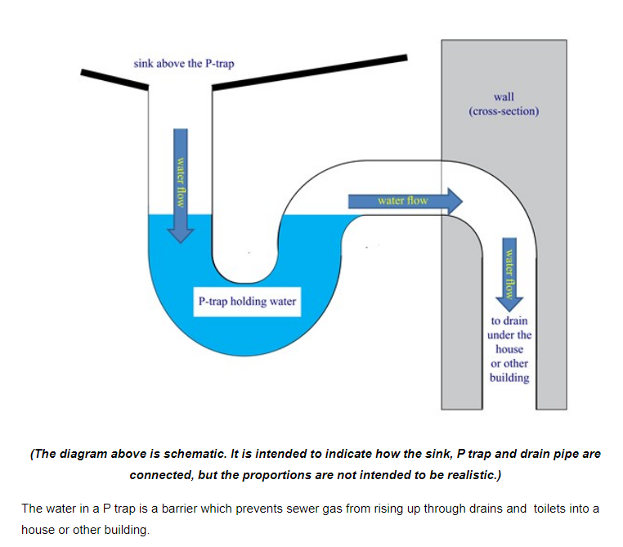

WWD Wastewater drain

**Appendix 1 – reproduced from NHMRC Guidelines**

**Point-of-use fixtures**

Water fixtures such as sinks, faucets, aerators, showers, and toilets have been identified as potential reservoirs for pathogenic microorganisms[393][395][403][408]. Such fixtures produce aerosols that can disperse microbes and they have wet surfaces on which moulds and other microorganisms can proliferate. However, empirical evidence linking these fixtures to HAIs is still limited; no consensus has been reached regarding the disinfection or removal of these devices for general use[406].

Regular cleaning, disinfection and preventative maintenance programs should be provided, especially in areas housing immunocompromised patients.

**Appendix 2 – reproduced from NHMRC IC Guidelines 2019**

**SCRUB SINK/TROUGH**

This is a long sink that can accommodate one or more staff scrubbing for a surgical procedure (see

Standard Components: Room Data and Room Layout Sheets - Scrub Up / Gowning).

**TAPS AND WATERSPOUTS**

The use of spray taps and hoses is not supported in clinical environments as they create aerosols.

A domestic style single lever operation is considered an appropriate substitute for a wrist operated tap.

Clinical basins and scrub sinks or troughs should have waterspouts fitted with anti-splash devices.

Clinical basins and scrub sinks/troughs should have sufficient space between the waterspout and the basin, sink or trough to enable adequate washing up to the elbow.

Alignment of the waterspout should ensure the water flow does not run directly into the drain aperture, thus avoiding aerosol splashback to the hands and face of the user. The waterspout will be positioned to ensure the water flow hits at the front of the basin, sink or trough. For this reason, the selection of basins and tap ware should be coordinated and approved by clinical staff as a single unit.

For further details relating to taps and waterspouts, refer to the Standard Components of hand basins and scrub sinks.

Healthcare facilities should comply with Standards Australia, 2005, AS/NZS 3718:2005 Water Supply—Tap Ware.

**References**

Aranega-Bou, P., George, R. P., Verlander, N. Q., Paton, S., Bennett, A., Moore, G., . . . Woodford, N. (2019). Carbapenem-resistant Enterobacteriaceae dispersal from sinks is linked to drain position and drainage rates in a laboratory model system. *Journal of Hospital Infection, 102*(1), 63-69. doi:<https://doi.org/10.1016/j.jhin.2018.12.007>

Buchan, B. W., Graham, M. B., Lindmair-Snell, J., Arvan, J., Ledeboer, N. A., Nanchal, R., & Munoz-Price, L. S. (2019). The relevance of sink proximity to toilets on the detection of Klebsiella pneumoniae carbapenemase inside sink drains. *American Journal of Infection Control, 47*(1), 98-100. doi:<https://doi.org/10.1016/j.ajic.2018.06.021>

Carling, P. C. (2018) Wastewater drains: Epidemiology and interventions in 23 carbapenem-resistant organism outbreaks. In*: Vol. 39. Proceedings of the International Astronomical Union* (pp. 972-979).

Gormley, M., Templeton, K., Kelly, D., & Hardie, A. (2014). Environmental conditions and the prevalence of norovirus in hospital building drainage system wastewater and airflows. *Building Services Engineering Research & Technology, 35*(3), 244-253. doi:10.1177/0143624413485080

Kotay, S., Chai, W., Guilford, W., Barry, K., & Mathers, A. J. (2017). Spread from the Sink to the Patient: In Situ Study Using Green Fluorescent Protein (GFP)-Expressing Escherichia coli To Model Bacterial Dispersion from Hand-Washing Sink-Trap Reservoirs. *Appl Environ Microbiol, 83*(8), e03327-03316. doi:10.1128/AEM.03327-16

Kotsanas, D., Wijesooriya, W. R., Korman, T. M., Gillespie, E. E., Wright, L., Snook, K., . . . Stuart, R. L. (2013). "Down the drain": carbapenem-resistant bacteria in intensive care unit patients and handwashing sinks. *Med J Aust, 198*(5), 267-269. doi:10.5694/mja12.11757

Parkes, L. O., & Hota, S. S. (2018). Sink-Related Outbreaks and Mitigation Strategies in Healthcare Facilities. *Current Infectious Disease Reports, 20*(10). doi:10.1007/s11908-018-0648-3